Far East Victoria Landcare

Future Plan
2019-2023

September 2019

Far East Victoria Landcare

Far East Victoria Landcare (FEVL) plays a unique and important role in supporting the sustainability and well-being of the communities of far east Victoria.

By taking a whole-of-community approach, FEVL not only works to enhance the natural environment and the sustainability of agriculture and land use, but also addresses issues affecting the social capacity of communities of the region.

Formed in 2006, FEVL is a network of Landcare and Interest groups in fareast
Gippsland:

- Cabbage Tree Creek Landcare
- Cann Valley Landcare
- Goongerah Landcare
- Jarrahmond Landcare
- Marlo Landcare
- Snowy West Landcare
- Wairewa and District Landcare
- East Gippsland Bee Care
- Sustainable Agriculture

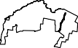
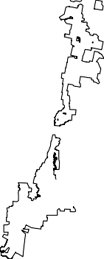
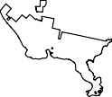
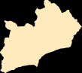
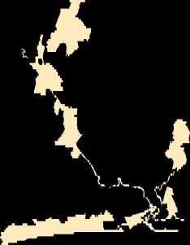
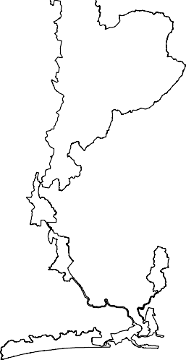
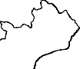
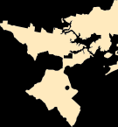
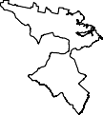
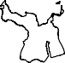
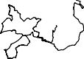
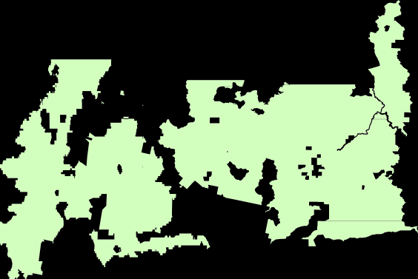
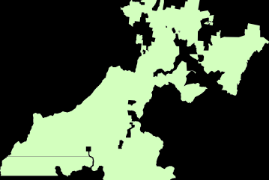
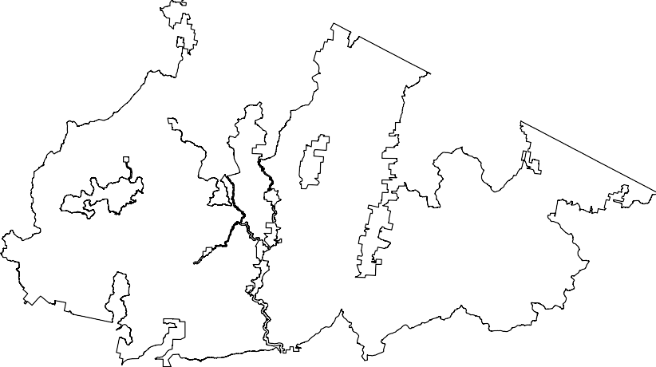
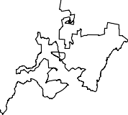
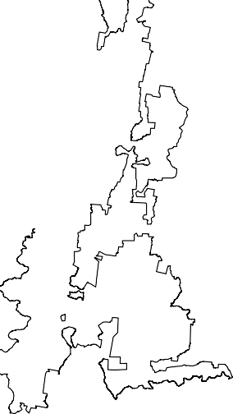
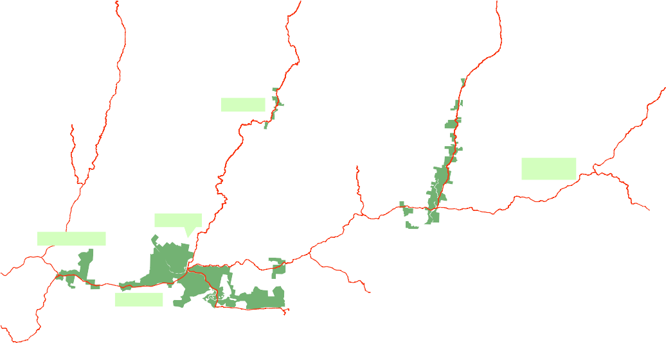
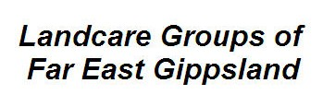
They encompass an area ranging from Nowa Nowa to the NSW border and from Goongerah in the north to the coast.
Ü
Goongerah
Cann Valley
Wangarabell -
Nungatta
Jarrahmond
Wairewa & District
Marlo
Snowy West
Legend
Landcare Areas
Land Tenure
Private Land Parks Reserves Public Land State Forest
Highways/Arterial Road

FEVL is governed by a committee of representatives from each of the Landcare groups and is supported by a small team of staff based in Orbost.

FEVL also hosts and manages the Regional Agricultural Landcare Facilitator project for the region, and employs the RALF. A separate Steering Committee guides the activities of the RALF.

Landcare and the region

Since its formation, FEVL has been successful in:
- Securing funding to maintain the employment of Landcare support staff
- Resourcing on-ground works and community activities
- Leveraging investment for the region
- Gaining the trust of the community
- Advocating for the needs of the far east Gippsland community
- Creating and maintaining strong cooperative liaisons
- Increasing access to a broad spectrum of information and expertise
- Supporting innovation in agriculture
- Providing leadership in and innovative approaches to supporting practice change.

In looking ahead, FEVL has identified the following trends and characteristics of the region which will influence the role of FEVL and Landcare in future:
  - The region is geographically isolated with a number of dispersed small communities that have a strong and increasing reliance on volunteers for their social well-being.
  - Climate change is predicted to have increasing social and economic effects. There is a growing need for sound understanding of the science and for adaptation and mitigation measures including recognition of increased risk and increased opportunities
  - Ownership and use of land is changing in some parts of the region where there is increasing demand for lifestyle properties. New residents in rural areas tend to have different interests and needs in relation to land management compared to long-term landholders.
  - The region is increasingly characterised by an ageing demographic, with implications for farm succession, employment opportunities for younger people and participation in many community groups.
  - The natural environment of the region is generally in very good condition (relative to other parts of Victoria) as a large proportion of the land is within National Parks. This can mean that government investment in natural resource management, and in Landcare projects in this area are given a low priority by funding agencies
  - Many landholders have been actively involved in Landcare for 20 years or more. Some groups have achieved their original goals and have broadened their activities to include education, information distribution and social connectivity. Some groups have seen membership decline, burnout of leaders and reduced participation in activities.
  - To stay relevant, Landcare groups will need to be responsive to a more diverse community and range of expectations.
  - Government policies and priorities for natural resource management continue to shift over time. It can be difficult for Landcare to maintain continuity of investment and deliver some activities important to members. There is a need to be well informed of new funding opportunities that emerge
  - State government agricultural extension services have been largely withdrawn. Landcare has taken on increasing responsibility to fill the gap
  - There are different perceptions within the community about what the purpose of Landcare is in the region, e.g. ‘only for farmers’ or ‘it’s about planting trees’. These perceptions can hinder broader participation in Landcare.

So what does this mean for FEVL?

There are three significant directions highlighted for FEVL:
- Revitalise Landcare – celebrate successes, define purpose, set new goals and motivate and re-energise committee and staff members.
- Be proactive – keep abreast of changes in our environment and in government policy and programs Recognise opportunities that arise
- Be innovative – build partnerships, learn from others, raise Landcare’s profile, find a niche, take considered risks and new approaches.

What does FEVL want to achieve long-term?

Vision:

Member groups which are vibrant, innovative and influential in their local communities with the network recognised as an organisation that provides strong leadership on environmental health and the agricultural sustainability* of far east Victoria.

*Sustainability meaning using natural resources without destroying or depleting.
This meaning includes “Resilience” – the ability of a system to recover quickly from setbacks

What will FEVL do to get there?

Mission:

Over the next five years, FEVL will contribute to the vision by:

- Providing support to member Landcare groups
- Providing current information on natural resource management and resilient farming systems to members and the broader community
- Providing current information to the community about ways of living sustainably
- Providing a hub for people and resources
- Advocating for community interests at a regional, state and national scale
- Creating and supporting social networks
- Building the skills and knowledge of the community
- Promoting Landcare participation/volunteerism
- Planning and managing projects at a network scale
- Building partnerships with other organisations that complement our purpose
- Being well informed of emerging funding opportunities
- Matching groups’ and network priorities to investment opportunities.

Landcare ethic
The work of the FEVL network is guided by the following six values. These values describe the Landcare ethic or philosophy, which underpins FEVL as a community organisation.

Environmental Stewardship

We are environmental stewards, working together to help create a healthy environment now and for the future.

Community

We are inclusive, trusted and non-threatening and welcome the involvement of all of the community (urban residents, small landholders, commercial farmers).

Local

We draw on the local agricultural and environmental knowledge, skills and expertise of our members, volunteers and partners to develop locally relevant solutions to environmental issues.

Leadership
We are leaders in local natural resource management planning.

Independent

We are a community driven organization and maintain the flexibility to be responsive to new or emerging issues of local importance.

Quality
We continually strive to adopt the best and most effective ways of implementing our business including on-ground works, community engagement, information brokering and network governance.

Objectives

An effective Network committee

The committee of the FEVL network is responsible for the strategic direction and performance of the organisation. The committee is made up of two volunteer representatives from each of the member Landcare and interest groups.

A significant challenge for the FEVL committee is the ‘tyranny of distance’. Member groups are situated mainly along isolated river valleys and flats and so have long distances to travel to attend committee meetings and Landcare events.

The FEVL committee needs to maintain a balance between manageable workloads for all committee members and staff and appropriate governance processes for a Landcare network of this size.

A more even distribution of the management workload is needed to better utilise the collective skills and experience among the committee. This should also ensure committee leaders (president, vice president, secretary, treasurer) and staff do not become worn out.

Succession planning for the FEVL committee is needed to ensure that new people are recruited on a regular basis and mentored by more experienced committee members.

The Committee has two distinct roles – Governance is one, Project development is the other

Actions
    - Committee processes tailored to members needs
- Review meeting processes to ensure meetings are engaging and relevant for members
- Reduce the requirement for committee members to travel (e.g. use of phone conferences, Skype)
- Actively promote opportunities for new and/or young people to participate on the committee
- Celebrate successes

Share the workload across committee members
- Allocate roles for all committee members that are tailored to their knowledge, skills and interests
- Develop/maintain sub-committees or individual responsibilities within the FEVL committee that take responsibility for specific tasks (e.g. Finance, Human Resources Organisation Performance (executive committee), Funding, Group Support, Communications, Projects).

Supported and healthy member groups

FEVL has an important role in supporting its member Landcare groups.

Each Landcare group has its own goals, opportunities and challenges and FEVL is well-positioned to develop and/or support activities tailored to meet the needs of each group.

Actions
- Build an understanding of member group needs
- Build in a regular report to the committee on group health/needs
- Support groups to regularly review and update their goals (action plans)
- Support groups to address challenges on an as needs basis
- Act as an advocate on behalf of member groups.
- Provide group members with information on what other groups are doing

Strong networks and partnerships

To enable Landcare to achieve its goals, it is important to build and maintain productive partnerships with a range of stakeholders and organisations who can provide information, skills, labour, technical advice and financial support.

An important role of FEVL is to build partnerships in the local communities (e.g. schools, community groups, businesses, local government, public land managers) and at the regional and state scales (e.g. with CMA, DELWP, Agriculture Victoria, Landcare Victoria, universities and research groups).

Building partnership with stakeholders and organisations at a regional and state scale is also an important source of:
- Innovative ideas, resources and solutions to common problems, and
- Latest technical, policy and strategy information with regard to building community skills in natural resource management and sustainable agriculture.

Actions
- Build strategic partnerships
- FEVL will build strategic and productive partnerships by utilising networking opportunities.
- Where possible FEVL will link communities of interest and connect different user groups to enable the sharing of resources, projects and ideas

Act as leaders and innovators
- FEVL will actively look for knowledge and innovation both locally and further afield and both inside and outside Landcare

Increased community awareness and participation in Landcare

Landcare is one of the few community organisations that remain in some far east Gippsland communities. FEVL and its member groups therefore could play an extremely important role in building social networks across a number of isolated rural communities. Landcare contributes to social connectivity and the health and wellbeing of communities in the far east.

Landcare is also a major provider of relevant and up-to-date information on sustainability, natural resource management and sustainable agricultural in the far east.

FEVL will continue to raise awareness and involvement in Landcare amongst the broader community through a range of communication activities and events. These events can also be used as a means to provide information to the community on emerging issues and opportunities.

Actions
- Improve the profile of FEVL
- Continue to develop FEVL’s communications tools (e.g. website, social media, videos, newsletter, local media and display banners)
- Organise events and activities of general interest to the broader community where FEVL and what Landcare has to offer can be promoted
- Ensure all Landcare activities are available to non-members to attend

Encourage Landcare participation
- Encourage and support Landcare events and activities with local primary and secondary schools
- Development and distribution of a ‘Landcare Welcome Pack’ on behalf of all member Landcare groups

Provide relevant and up-to-date information on sustainability, natural resource management and sustainable agriculture to the community
- Share local innovation and research
- Bring technical expertise into the region
- Collate and distribute scientific/policy information

Projects delivered to meet community needs

The communities of Far East Gippsland are diverse and there is a multitude of reasons why people may become involved in Landcare (For example commercial farmers, small landholders or those who dwell in small towns) . FEVL must retain the ability to be flexible and to readily adapt to meet varying needs. We must continue to work hard to be innovative in how we support people to achieve good ecosystem service outcomes,
At the same time this diversity presents a challenge for FEVL, as there is a risk of our resources being over-stretched in order to meet the evolving needs of existing and emerging demographics within our communities.

Actions
9. Develop projects in response to community need
- Identify community needs through annual planning processes and an Expression of Interest process.
- Be innovative in developing local projects and matching these local priorities to investment and other resource opportunities
- Draw on external expertise to inform project planning and implementation where necessary

Summary of Actions

Number | Action
1 | Committee processes tailored to member needs.  -Penny to approach Cann Valley, Cabbage Tree and Goongerah members about interest in remote call in participation in CoM meetings and about CoM visiting and becoming familiar with their Projects/activities
2 | Share the workload across committee members.  -Committee members to advise of any support/training they would find helpful to their roles eg Project development/management  -Committee to advise of others who could contribute to a Project development “brainstrust”
3 | Build an understanding of member group needs  -Committee members regularly report on group needs. Stephen to draft a template for CoM members to enable straightforward input from group members –ongoing  - PG to let groups without current delegates know of this
4 | Build strategic partnerships – ongoing as opportunities arise or are  needed
5 | Act as leaders and innovators – ongoing as evident in for eg TopSoils activities. Participants and outsiders have noted and commented favourably on this.  - Continue to communicate, particularly through social media, such activities and links to other innovative organizations
6 | Improve the profile of FEVL  - Continue to develop FEVL’s communication tools  - CoM members encourage groups awareness and use of e.g. FEVL Facebook content for news and updates  - Participate in Landcare contribution in Orbost Ag Society Show 2020. CoM members seek group input - ideas and organizing assistance  - -Celebrate successes  - - Finance and CoM to discuss types of events and funding available
7 | Encourage participation in Landcare – as above  - CoM members float the idea of groups developing a Welcome Pack for newcomers to their area  - CoM members float idea that groups invite schools participation in relevant group activities
8 | Provide relevant and up-to-date information on sustainability, natural resource management and sustainable agriculture to the community  -Continue resource use projects eg recycling project  - see above (6 and 7) for methods
9 | Develop projects in response to community need  -Continue to host and support the RALF position and its focus on Agriculture and the management of smaller landholdings  - Identify community needs through annual planning processes and an Expression of Interest process.  - Match these local priorities to investment and other resource opportunities  -Draw on external expertise to inform project planning and implementation where necessary

